# Java Web Development Basics

# Spring Workshop – Part One

# Heroes

Heroes is an web application where you can find vvictorious opponents. Database Requirements

The **Database** of the application needs to support:

### User

* Has a Username - String
* Has a Password - String
* Has an Email - String
* Has a Hero - **Entity**

### Hero

* Has a Username - String
* Has a Gender – (Male, Female)
* Has a Level - Integer
* Has a Stamina - Integer
* Has a Strength - Integer
* Has an Attack - Integer
* Has a Defence - Integer
* Has a List<HeroItems>(Inventory)
* Has User - Entity

### Item

* Has a Name - String
* Has a Slot(Weapon, Helmet, Pauldron, Pads, Gauntlets)
* Has a Stamina - Integer
* Has a Strength - Integer
* Has an Attack - Integer
* Has a Defence - Integer

### Hero Items

* Has a Hero - Entity
* Has an Item - Entity

## Templates

### Index Template (route = “/”) (logged out user)

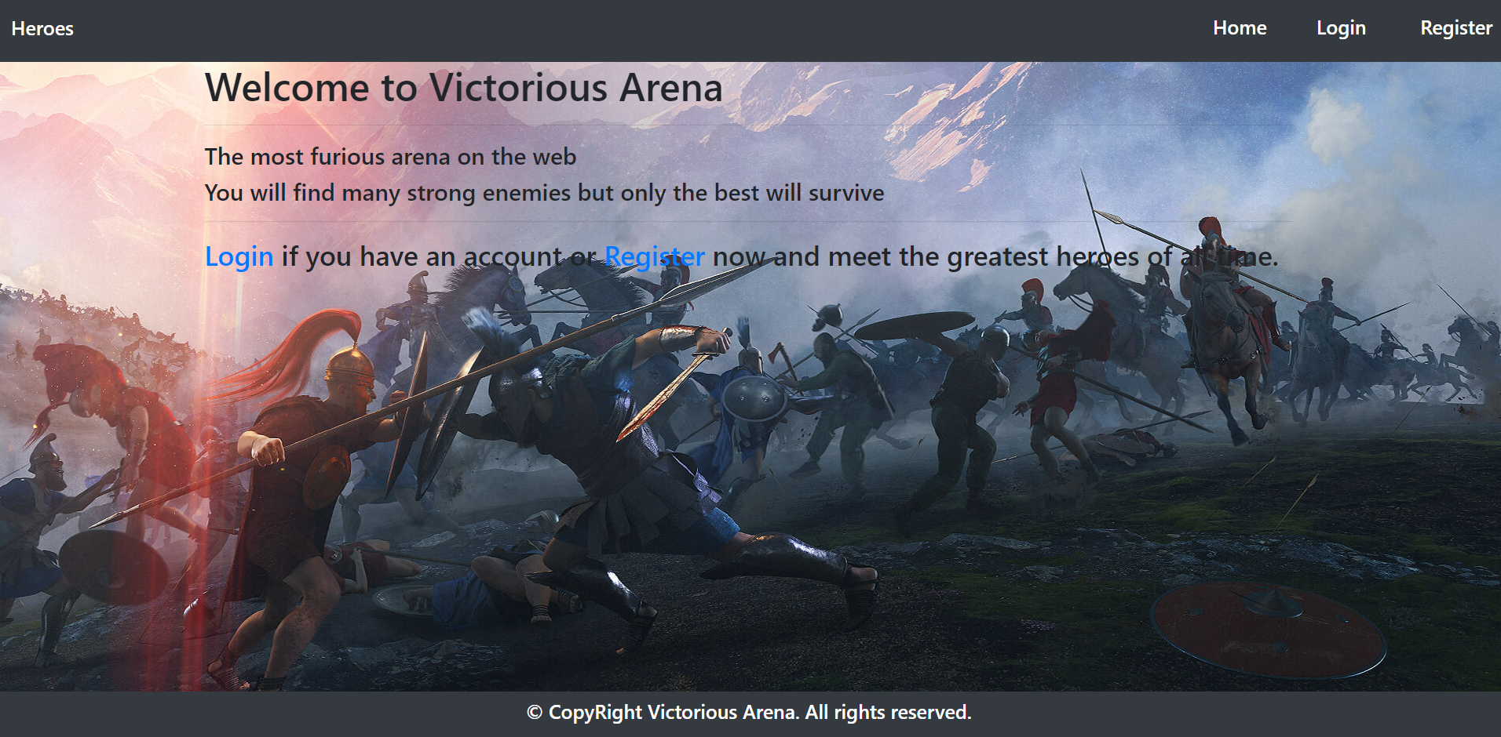

### Login Template (route = “/users/login”) (logged out user)

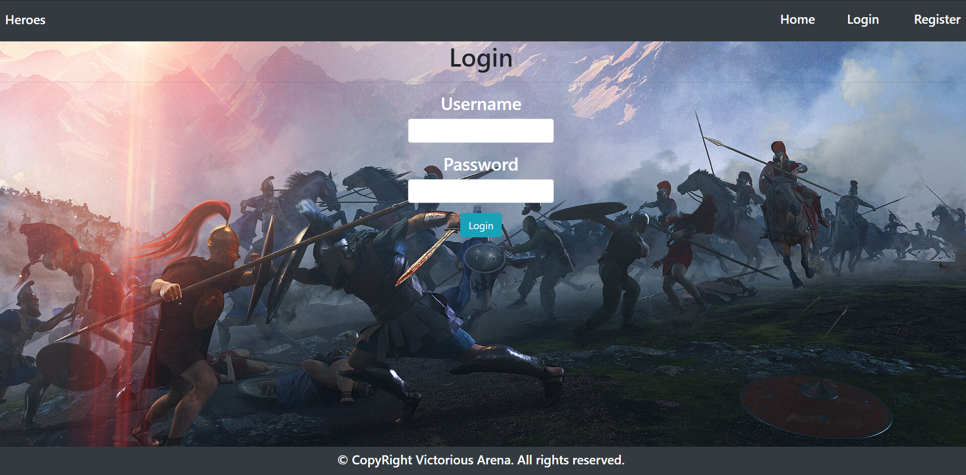

### Register Template (route = “/users/register”) (logged out user)

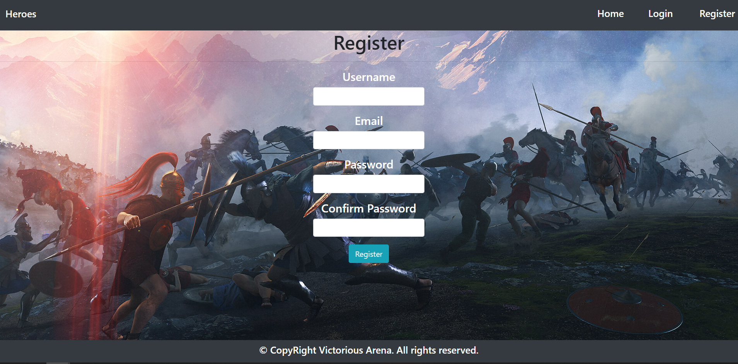

### Home Template (route=”/home”) (logged in user)

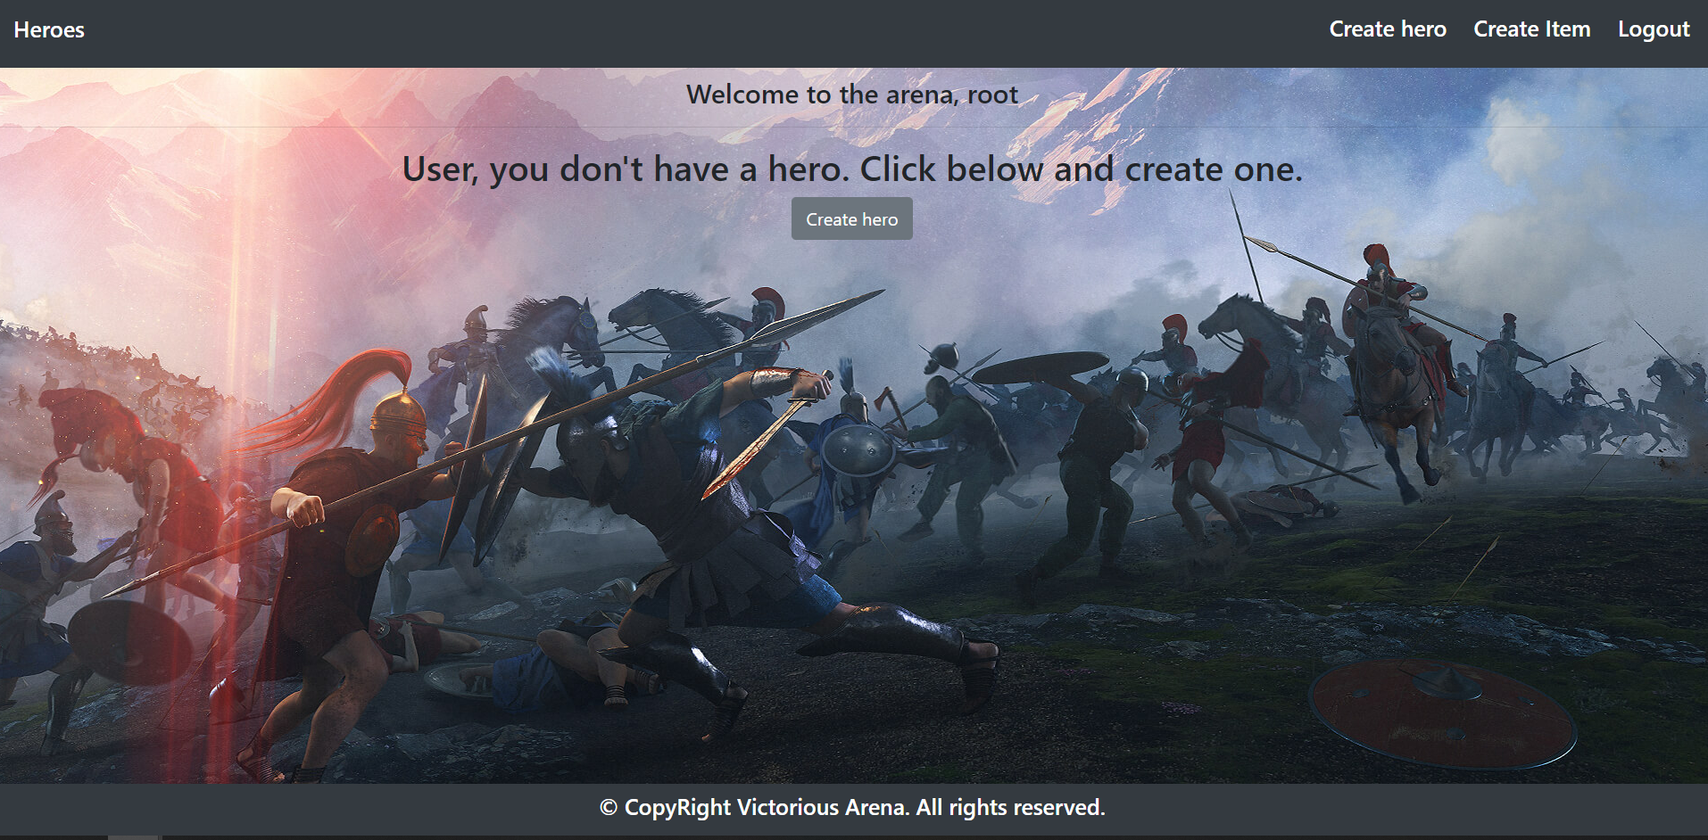

### Hero Create Template (route=”/heroes/create”) (logged in user)

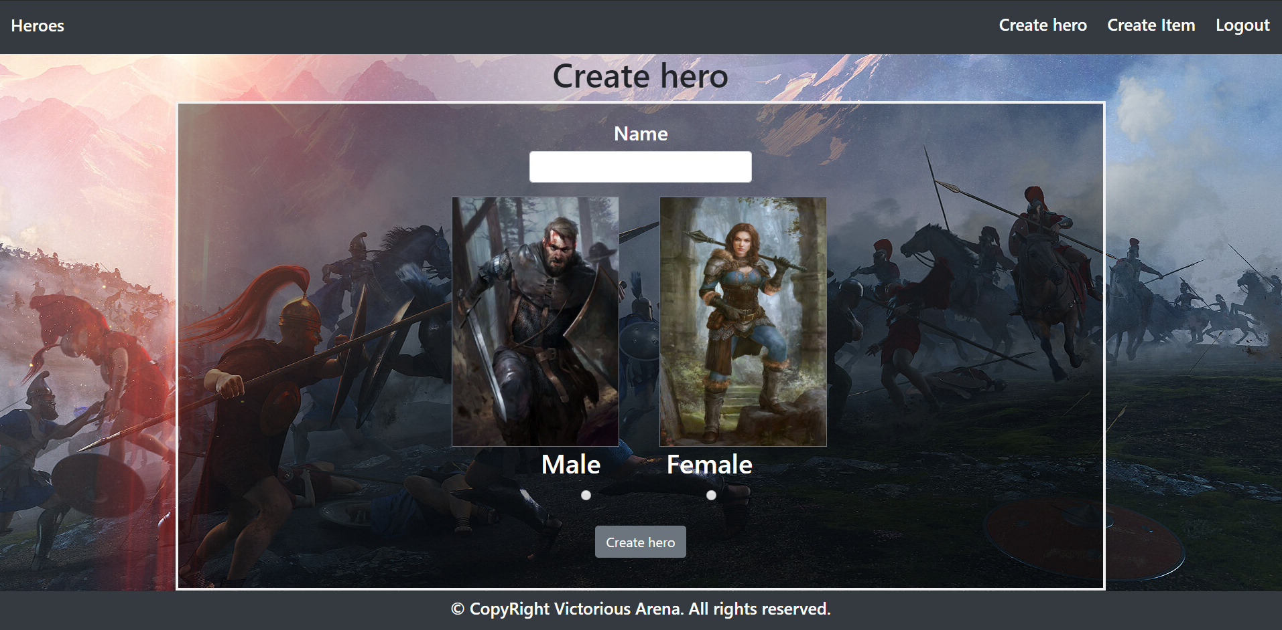

### Home Template (route=”/home”) (logged in user)

Home after hero is created.

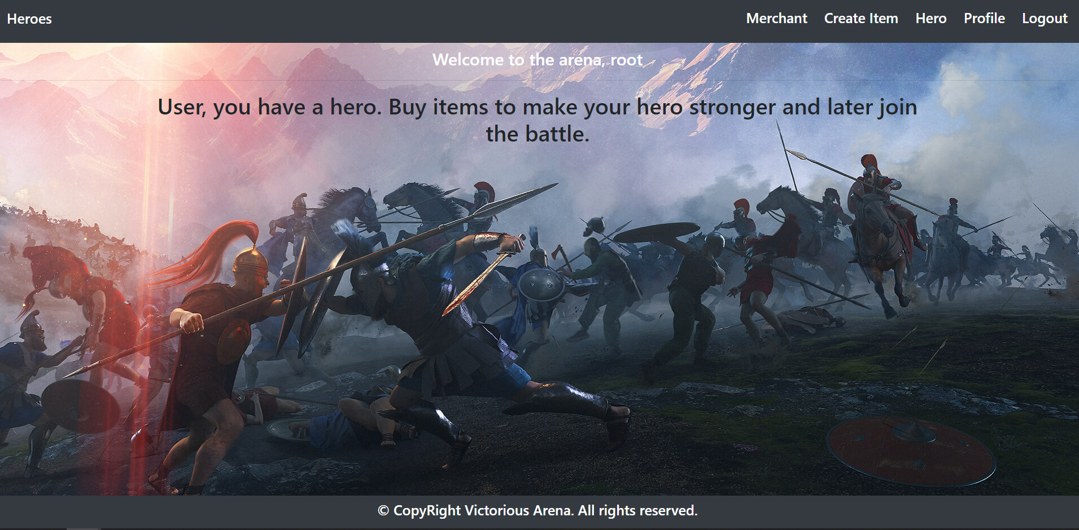

### Profile Template (route=”/users/profile”) (logged in user)

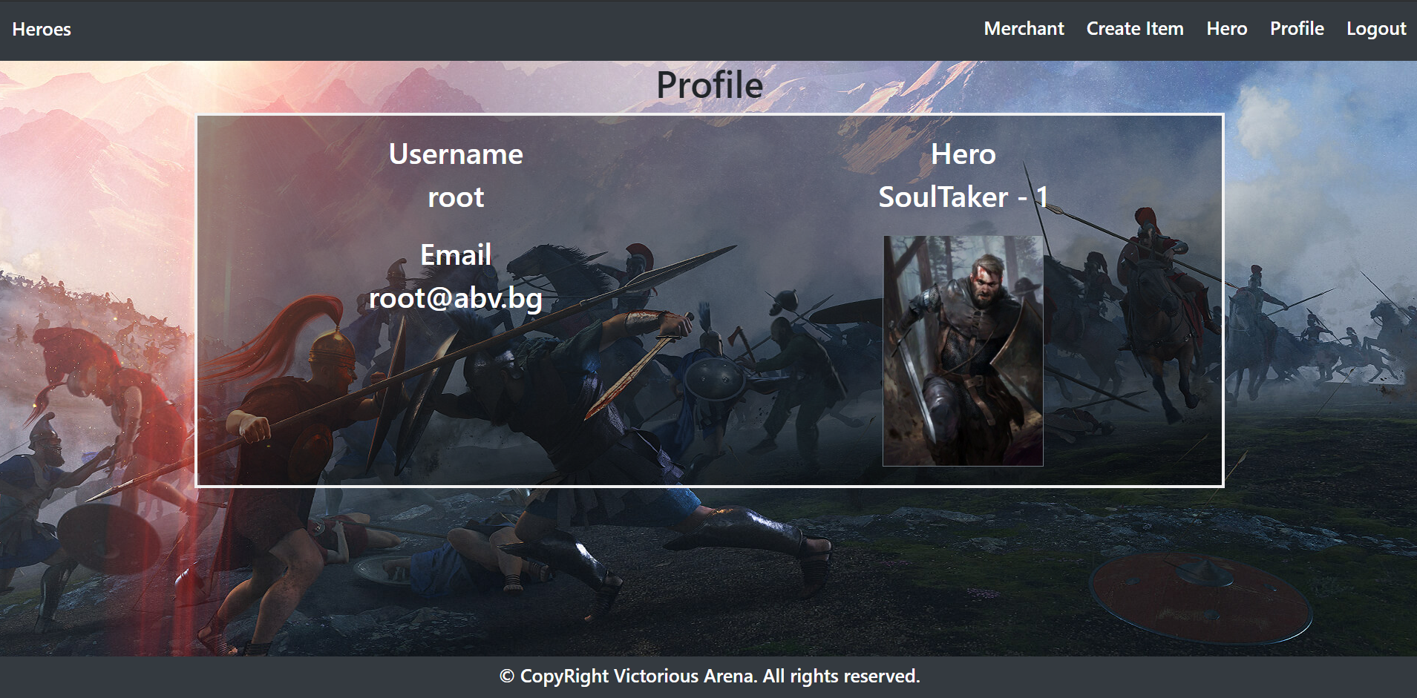

### Hero Details Template (route=”/heroes/details/(name)”) (logged in user)

**Hero details when we don't have items**

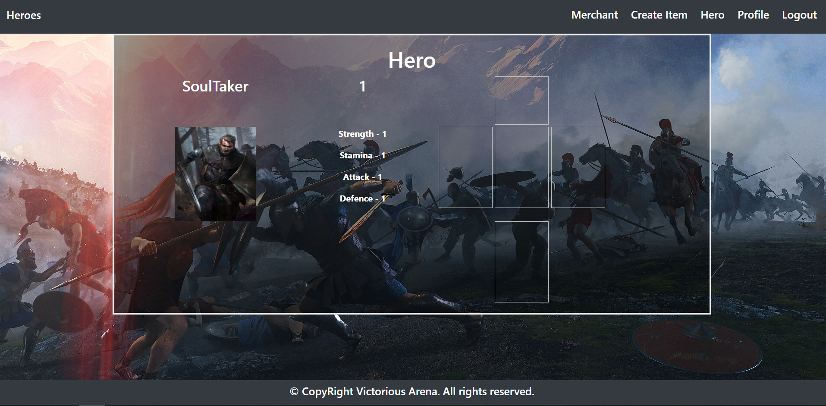

### Create Item (route=”/items/create”) (logged in user)

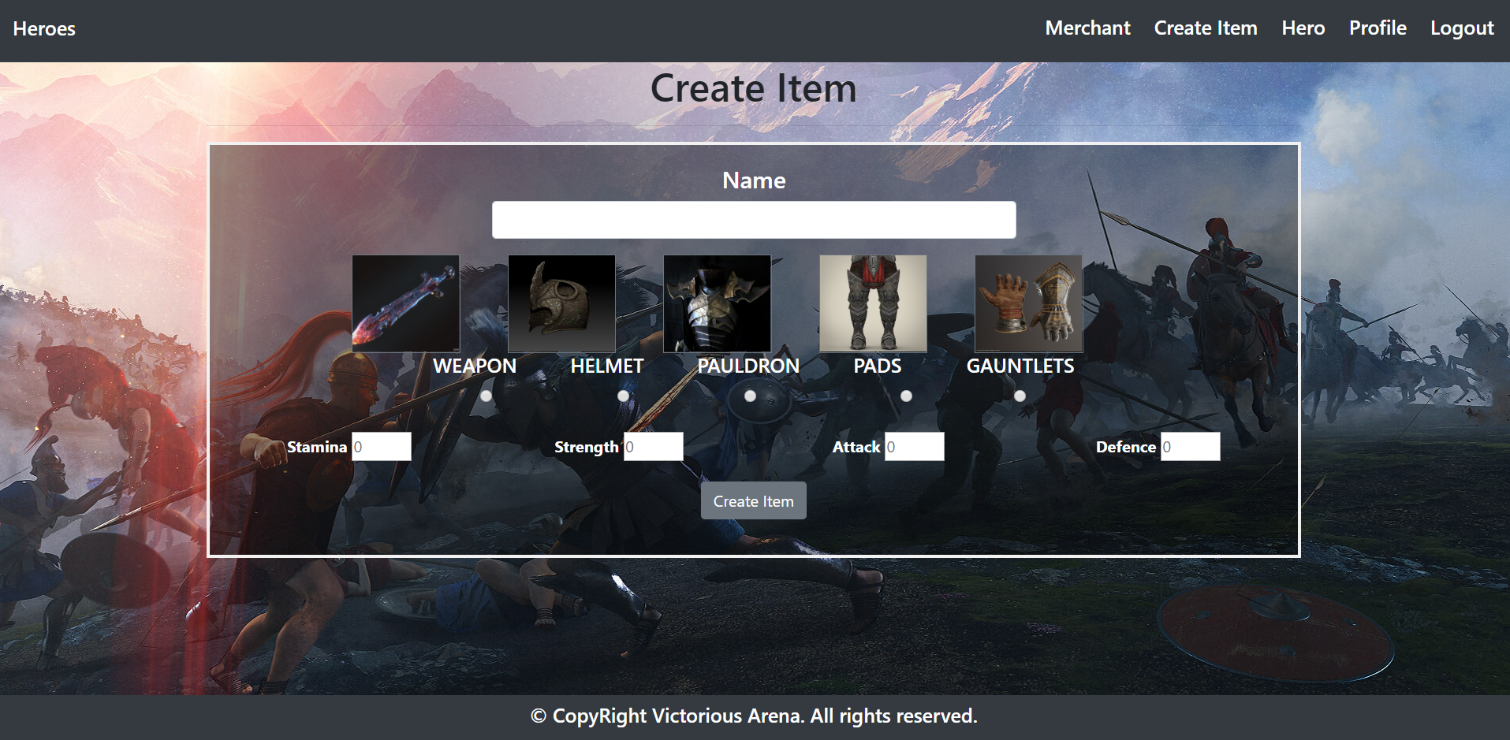

### Merchant (route=”/items/merchant”) (logged in user)

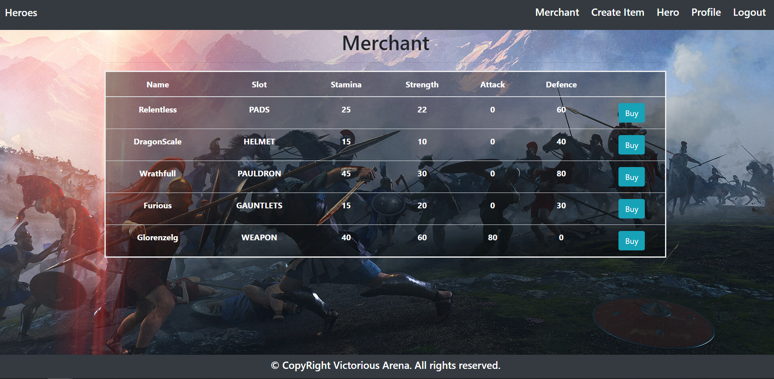

### Hero Details (route=”/heroes/details/(name)”) (logged in user)

H**ero details after we buy items.**

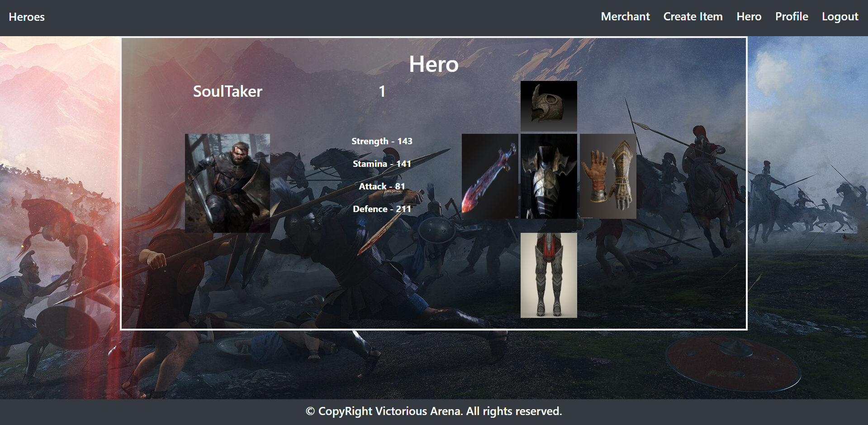

## Functional Requirements

The Functionality Requirements describe the functionality that the **Application** must support.

The **application** should provide Guest (not logged in) users with the functionality to:

* Login
* Register
* **View** the Index page.

The **application** should provide Users (logged in) with the functionality to:

* Logout
* Home
* Create Hero
* Create Item
* Profile
* Hero Details
* Merchant

**User** can have can only one **Hero**. When **user has created a hero**, he can access **Merchant** and **Profile** functionality.

On **profile** page you should see **User** – **username** and **email**, **Hero** – **name**, **level** and **gender**(appropriate picture).

After you **create a item**, it should appear in **Merchant** page. Each item needs to be shown in table like in the photo. When hero **buys** a item it will be added to his **inventory**. Hero can have only **one** weapon, helmet, pauldron, gauntlets or pads. After he **buys** a item, the item **buy** button should be **hidden**. When a hero buys a item his **stats** need to be **updated** with the **item** **stats**.